Day-3 : Student Management Spring - 1,2
Screen Shots (Desktop):
Home Page:

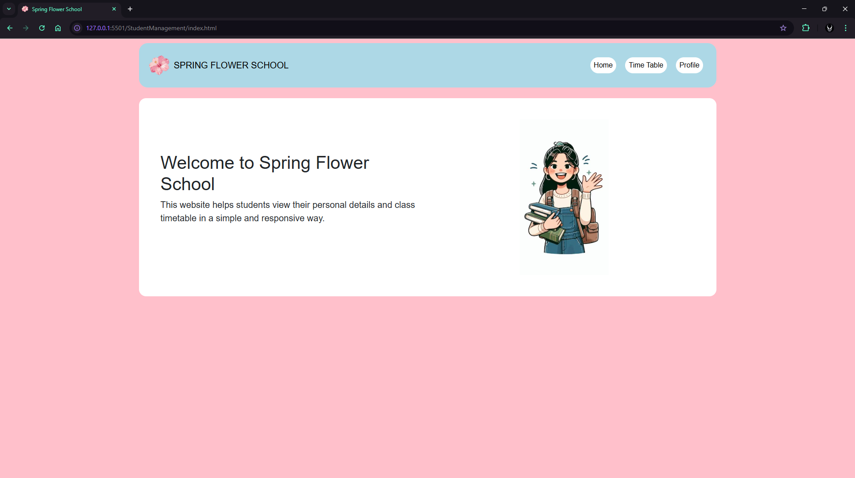

Time Table Page:
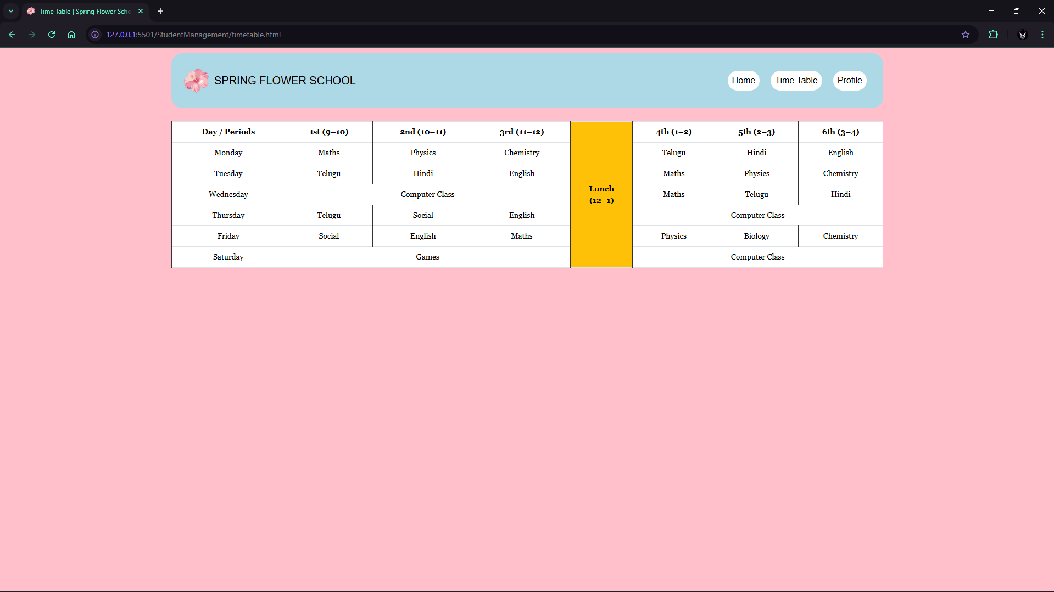

Profile Page:

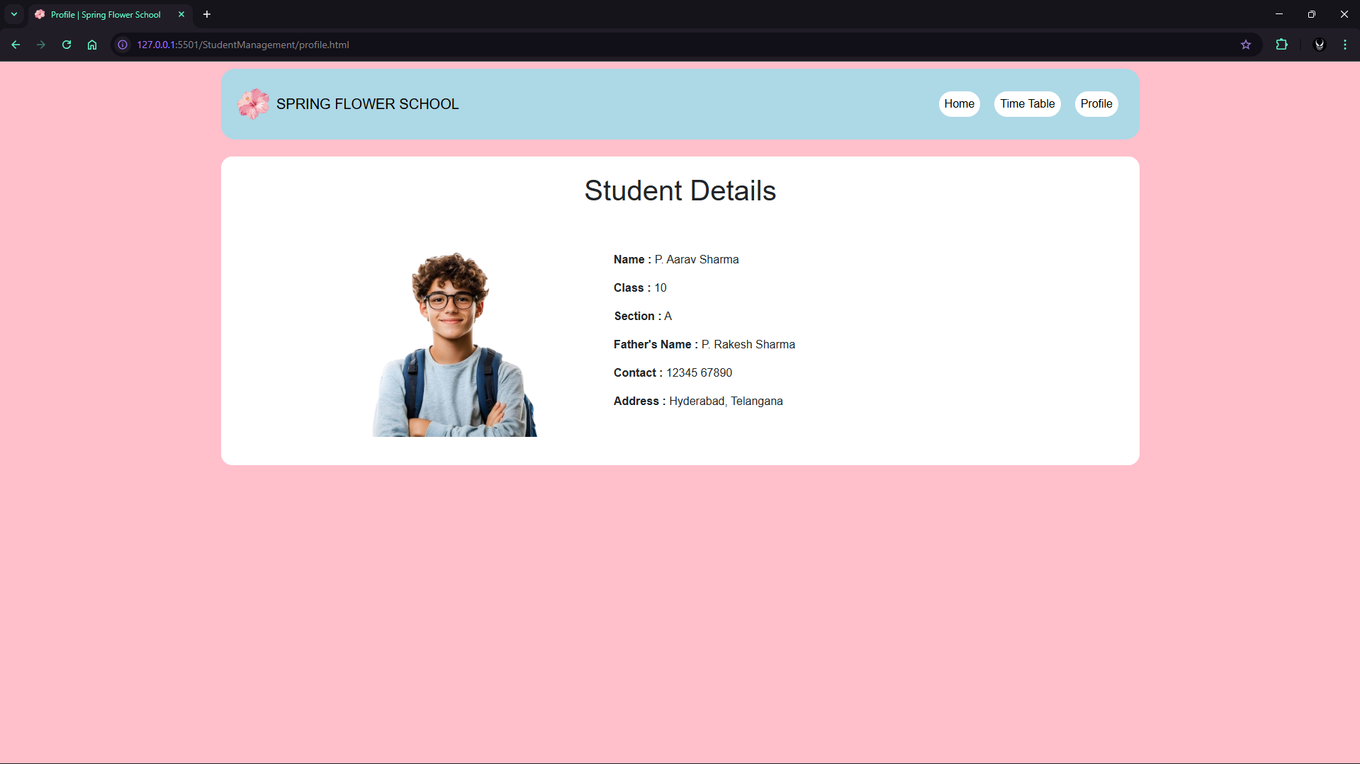

Screen Shots (Mobile):
Home Page: Time Table Page: Profile Page:
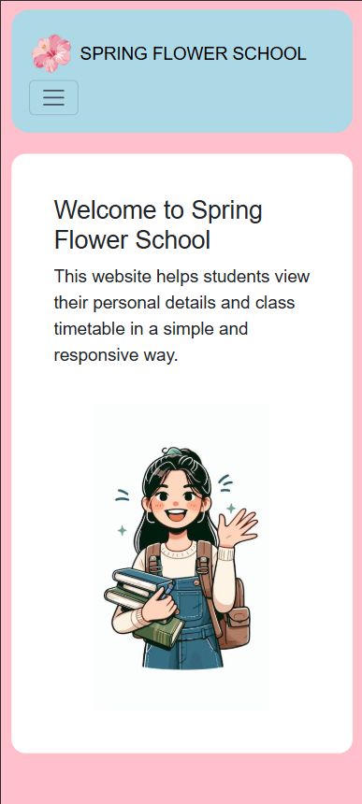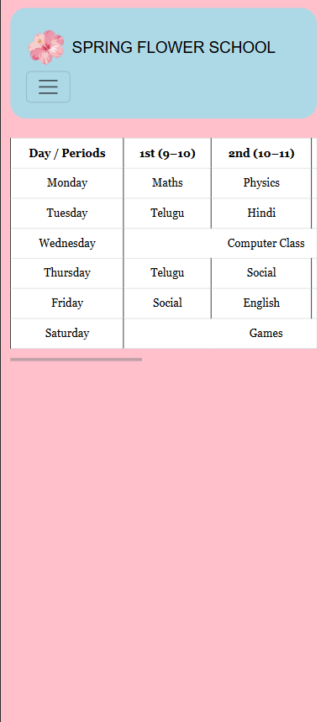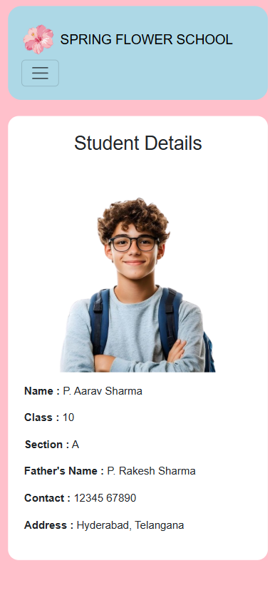

HTML CODES:
Index.html:
<!doctype html>
<html lang="en">
<head>
<meta charset="UTF-8" />
<meta name="viewport" content="width=device-width, initial-scale=1.0" />
<title>Spring Flower School</title>
<link rel="icon" href="./Images/SpringLogo.png" />
<link href="https://cdn.jsdelivr.net/npm/bootstrap@5.3.3/dist/css/bootstrap.min.css" rel="stylesheet" />
<script src="https://cdn.jsdelivr.net/npm/bootstrap@5.3.3/dist/js/bootstrap.bundle.min.js"></script>
<link rel="stylesheet" href="./styles.css" />
</head>
<body>
<header>
<div class="container">
<nav class="navbar navbar-expand-md navbar-light" style="padding: 20px;">
<a class="navbar-brand d-flex align-items-center gap-2" href="index.html">
<img src="./Images/SpringLogo.png" height="50" />
<span>SPRING FLOWER SCHOOL</span>
</a>
<button class="navbar-toggler" data-bs-toggle="collapse" data-bs-target="#mainMenu">
<span class="navbar-toggler-icon"></span>
</button>
<div class="collapse navbar-collapse" id="mainMenu">
<ul class="navbar-nav ms-auto">
<li class="nav-item"><a class="nav-link active" href="index.html">Home</a></li>
<li class="nav-item"><a class="nav-link" href="timetable.html">Time Table</a></li>
<li class="nav-item"><a class="nav-link" href="profile.html">Profile</a></li>
</ul>
</div>
</nav>
</div>
</header>
<main class="container my-4">
<div class="bg-white rounded-4 p-5">
<div class="row align-items-center">
<div class="col-lg-6 mb-4">
<h1>Welcome to Spring Flower School</h1>
<p class="fs-5">
This website helps students view their personal details and class
timetable in a simple and responsive way.
</p>
</div>
<div class="col-lg-6 text-center">
<img src="./Images/girlholdingbooks.jpg" class="img-fluid" style="max-height:350px;" />
</div>
</div>
</div>
</main>
</body>
</html>

timetable.html:
<!doctype html>
<html lang="en">
<head>
<meta charset="UTF-8" />
<meta name="viewport" content="width=device-width, initial-scale=1.0" />
<title>Time Table | Spring Flower School</title>
<link rel="icon" href="./Images/SpringLogo.png" />
<link href="https://cdn.jsdelivr.net/npm/bootstrap@5.3.3/dist/css/bootstrap.min.css" rel="stylesheet" />
<script src="https://cdn.jsdelivr.net/npm/bootstrap@5.3.3/dist/js/bootstrap.bundle.min.js"></script>
<link rel="stylesheet" href="./styles.css" />
</head>
<body>
<header>
<div class="container">
<nav class="navbar navbar-expand-md navbar-light" style="padding: 20px;">
<a class="navbar-brand d-flex align-items-center gap-2" href="index.html">
<img src="./Images/SpringLogo.png" height="50" />
<span>SPRING FLOWER SCHOOL</span>
</a>
<button class="navbar-toggler" data-bs-toggle="collapse" data-bs-target="#mainMenu">
<span class="navbar-toggler-icon"></span>
</button>
<div class="collapse navbar-collapse" id="mainMenu">
<ul class="navbar-nav ms-auto">
<li class="nav-item"><a class="nav-link" href="index.html">Home</a></li>
<li class="nav-item"><a class="nav-link active" href="timetable.html">Time Table</a></li>
<li class="nav-item"><a class="nav-link" href="profile.html">Profile</a></li>
</ul>
</div>
</nav>
</div>
</header>
<main class="container my-4">
<div class="table-responsive">
<table class="table table-bordered text-center align-middle">
<tr>
<td>Day / Periods</td>
<td>1st (9–10)</td>
<td>2nd (10–11)</td>
<td>3rd (11–12)</td>
<td rowspan="7" class="fw-bold bg-warning">Lunch<br>(12–1)</td>
<td>4th (1–2)</td>
<td>5th (2–3)</td>
<td>6th (3–4)</td>
</tr>
<tr>
<td>Monday</td><td>Maths</td><td>Physics</td><td>Chemistry</td>
<td>Telugu</td><td>Hindi</td><td>English</td>
</tr>

<tr>
<td>Tuesday</td><td>Telugu</td><td>Hindi</td><td>English</td>
<td>Maths</td><td>Physics</td><td>Chemistry</td>
</tr>
<tr>
<td>Wednesday</td><td colspan="3">Computer Class</td>
<td>Maths</td><td>Telugu</td><td>Hindi</td>
</tr>
<tr>
<td>Thursday</td><td>Telugu</td><td>Social</td><td>English</td>
<td colspan="3">Computer Class</td>
</tr>
<tr>
<td>Friday</td><td>Social</td><td>English</td><td>Maths</td>
<td>Physics</td><td>Biology</td><td>Chemistry</td>
</tr
<tr>
<td>Saturday</td><td colspan="3">Games</td>
<td colspan="3">Computer Class</td>
</tr>
</table>
</div>
</main>
</body>
</html>
profile.html:
<!doctype html>
<html lang="en">
<head>
<meta charset="UTF-8" />
<meta name="viewport" content="width=device-width, initial-scale=1.0" />
<title>Profile | Spring Flower School</title>
<link rel="icon" href="./Images/SpringLogo.png" />
<link href="https://cdn.jsdelivr.net/npm/bootstrap@5.3.3/dist/css/bootstrap.min.css" rel="stylesheet" />
<script src="https://cdn.jsdelivr.net/npm/bootstrap@5.3.3/dist/js/bootstrap.bundle.min.js"></script>
<link rel="stylesheet" href="./styles.css" />
</head>
<body>
<header>
<div class="container">
<nav class="navbar navbar-expand-md navbar-light" style="padding: 20px;">
<a class="navbar-brand d-flex align-items-center gap-2" href="index.html">
<img src="./Images/SpringLogo.png" height="50" />
<span>SPRING FLOWER SCHOOL</span>
</a>
<button class="navbar-toggler d-flex align-items-ends" data-bs-toggle="collapse" data-bs-target="#mainMenu">
<span class="navbar-toggler-icon"></span>
</button>
<div class="collapse navbar-collapse" id="mainMenu">
<ul class="navbar-nav ms-auto">
<li class="nav-item"><a class="nav-link" href="index.html">Home</a></li>
<li class="nav-item"><a class="nav-link" href="timetable.html">Time Table</a></li>
<li class="nav-item"><a class="nav-link active" href="profile.html">Profile</a></li>
</ul>
</div>
</nav>
</div>
</header>
<main class="container my-4">
<div class="bg-white rounded-4 p-4">
<h1 class="text-center mb-4">Student Details</h1>
<div class="row align-items-center justify-content-center">
<div class="col-md-4 text-center mb-3">
<img src="./Images/Profile.png" class="img-fluid" style="max-height:300px;" />
</div>
<div class="col-md-6">
<p><strong>Name :</strong> P. Aarav Sharma</p>
<p><strong>Class :</strong> 10</p>
<p><strong>Section :</strong> A</p>
<p><strong>Father's Name :</strong> P. Rakesh Sharma</p>
<p><strong>Contact :</strong> 12345 67890</p>
<p><strong>Address :</strong> Hyderabad, Telangana</p>
</div>
</div>
</div>
</main>
</body>
</html>

styles.css:
* {
margin: 0;
box-sizing: border-box;
}

body {
background-color: pink;
font-family: Arial, Helvetica, sans-serif;
}
nav {
background-color: lightblue;
padding: 10px;
margin-top: 10px;
border-radius: 20px;
}

nav img {
height: 50px;
}

.navbar-nav {
gap: 20px;
padding: 10px;
}

.navbar .nav-link {
background-color: white;
border-radius: 20px;
padding: 6px 18px;
color: black;
transition: 0.3s;
}

.navbar .nav-link:hover {
background-color: black;
color: white;
transform: scale(1.05);
}

@media (max-width: 768px) {
.navbar {
position: relative;
}

#mainMenu {
position: absolute;
top: 65px;
right: 10px;
background-color: lightblue;
border-radius: 18px;
padding: 12px;
width: 180px;
box-shadow: 0 8px 20px rgba(0,0,0,0.2);
z-index: 1000;
}

#mainMenu .navbar-nav {
flex-direction: column;
gap: 10px;
}

#mainMenu .nav-link {
text-align: center;
}
}
.main-box {
background: white;
border-radius: 20px;
min-height: 70vh;
padding: 30px;
}

.table-container {
width: 100%;
overflow-x: auto;
display: flex;
justify-content: center;
}

table {
border-collapse: collapse;
background-color: #fffbdc;
min-width: 900px;
}

table td {
border: 2px solid #333;
padding: 10px;
text-align: center;
font-family: Georgia, 'Times New Roman', serif;
font-size: 14px;
}

table tr:first-child td {
font-weight: bold;
}

table td[rowspan] {
background-color: #fff3a0;
font-weight: bold;
}
#slogan {
margin: 20px auto;
padding: 12px 24px;
background-color: lightcyan;
border-radius: 20px;
width: fit-content;
font-style: italic;
}

